**I'm making another batch for AMVETS "75 Years" swag!**

**Please let me know to reserve hats, pins or key chains**

**Forward to members who will have interest please**

**Also members at Veterans Homes & VAMC (they'll love 'em!)**

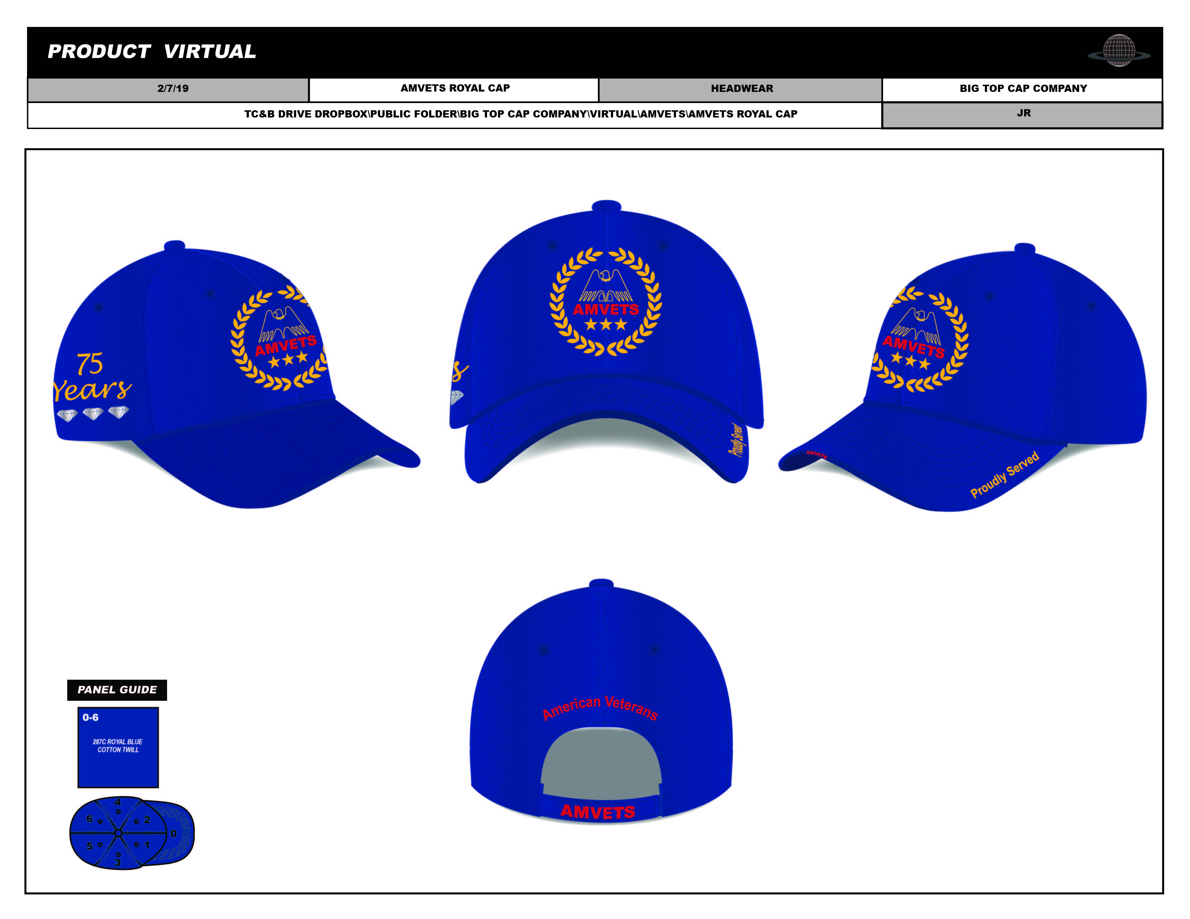

**\*open attached photos at bottom to view and enlarge**

**100% Cotton / 6 Panel Constructed / Velcro Rear Closure**

**Visor Sandwich + Visor Rope / Fully Embroidered Images**

**"75 Years" / "Proudly Served" / "American Veterans"**

**Hats $8.90 / Pins $5.25 / Dog Tag Key Chains $5.90**

**PHOTOS attached / all orders + USPS ground shipping**

**ALL ITEMS WILL BE COMPLETE AND READY TO SHIP IN 35-40 DAYS**

**1.75 inch pin with clasp            Actual 2 inch dog tag size key chain**

**$5.25 each + ship                      $5.90 each + ship**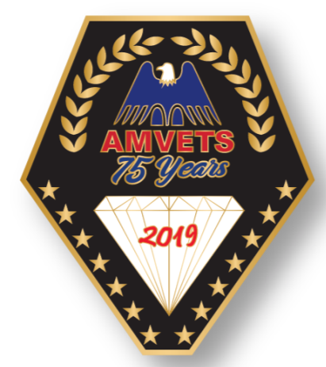             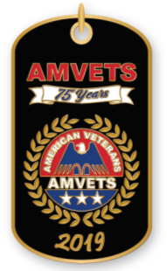

**BOTH ARE DIE CAST, ENAMEL FILLED WITH HIGH POLISHED FINISH**

**and for WWII VETERANS a classic 2 inch pin to honor them while we can!  (2 rear clasps keeps pin in place). Beautiful. Die cast & polished. Great for Veteran homes and VA hospitals too! About 40 remain / $5.90 each + ship**

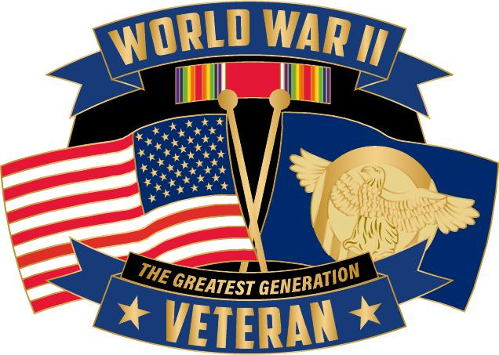

**CONTACT WILL to ORDER or with QUESTIONS**

**(844) VET-HATS /**[**VetHats@gmail.com**](mailto:VetHats@gmail.com)

PLEASE FORWARD TO ALL!

**Will**

**Big Top Cap Company**

**Myrtle Beach, SC**

**(844) VET-HATS / (844) 838-4287**

**A small operation with HUGE appreciation for our veterans!**